Assignment for Business Analyst Intern @Jar  
**Presented By:**  
Name: Shripad Kulkarni  
Email: [shripadkulkarni2212@gmail.com](mailto:shripadkulkarni2212@gmail.com)

Phone: 7378674911

Linkedin: <https://www.linkedin.com/in/shripad-kulkarni-candoit/>

Tool Used: Power BI

**1. Walmart Sales Analysis:**

You have been given a data set to analyse and answer the following questions:

Candidate can answer the questions by using any technical tool (Excel, Sheets,

Python, etc..)

Data Set: Walmart Sales [Kindly find an attached copy in the email]  
   
**A. Analyse the performance of sales and revenue at the city and branch level ( 5 marks)**

**Ans:**  
  
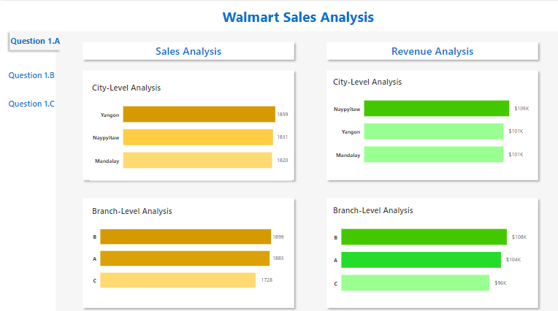

**B. What is the average price of an item sold at each branch of the city (10 marks)  
  
Ans:**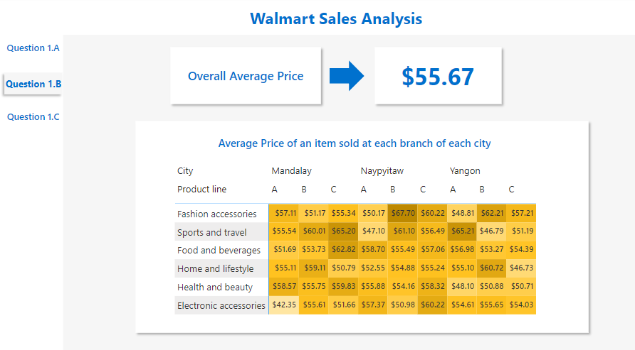

**C. Analyze the performance of sales and revenue, Month over Month across the**

**Product line, Gender, and Payment Method, and identify the focus areas to**

**get better sales for April 2019. (15 marks)**

**Ans:   
a. Month-over-Month Sales Analysis**

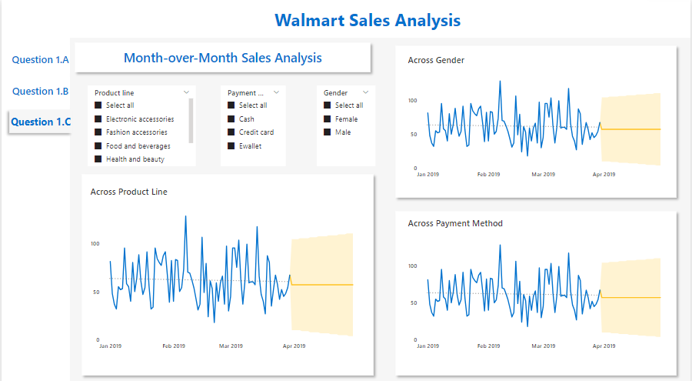

**b. Month-over-Month Sales Analysis**

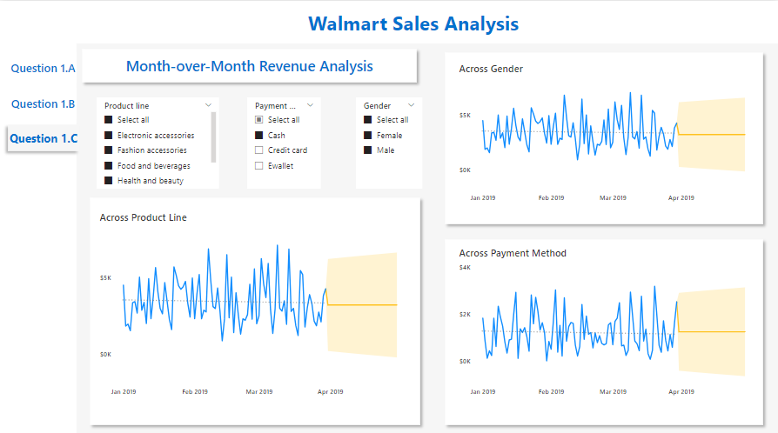

**2. App Exploration: (5 marks)**

**Explore the features and user experience of the Jar app. Identify two aspects that**

**you think could be significantly improved and explain your reasoning behind each**

**suggestion.**

**Ans:**

**Feature and User Experience of the App:**

1. The first important feature is that it provides an opportunity of saving money to people on a daily, weekly and monthly basis. One can start his savings with a minimum Rs10.
2. Second interesting feature of buying gold with minuscule amounts as low as Rs.50. The interface of the app is simple to navigate so that one can comfortably see the current price of Gold on the screen.

**Aspects that require improvement:**

1. **First Aspect** : The Colour Theme of the App

Reason:

1.1 The colour theme of the app is similar to UPI platform Phone Pe. Prima facie, it may create a preconceived notion in the mind of the user that Jar is a subsidiary company of Phone Pe. So in my opinion, we can change the design colour theme of the Jar App.

1.2. Also, Phone Pe is offering all the above mentioned features along with UPI payment facilities, so in the long run Jar may face the issue of User Retention as it is more convenient for someone to access all the financial matters (like Payment, Savings, Insurance, Bills ) at a single destination point.

1. **Second Aspect :** Lack of Adequate Analytics and Visualisation related to savings.

Reason:  
1.1 The basic human instinct about money and saving is that people love to check their total savings frequently.(This human instinct can be utilised for increasing engagement time of the user).

1.2. People love to associate fulfilment and satisfaction with the act of Wealth Generation. We love to compare and analyse our saving’s status over a period of time.

1.3. So we can include one analytics window in the app, which will keep showing the past track of our daily savings in graphical format (like line chart). We can show the rising investment trend in this graph. This will motivate people to invest more.

1.4.Currently it is showing only the absolute amount of savings done by any individual in number format.

1.5. We can add animations that evoke Nostalgia in users. For example, when any user makes a small transaction, we can show the animation of adding a coin in a piggy bank or a small pot/jar. This is our childhood memory and everyone can relate to it.

**3. Product Optimisation: (5 marks)**

**The Jar app has an engagement feature called 'Spin to Win'.**

**Right now, if 100 people come to the app each day, only 23 of them try out this**

**spinning game. But, we know that people who spin are more likely to retain on the**

**app and do transactions.**

**Now, we want to get more people to play the game. So, the question is, how can we**

**make sure that at least 50 people out of every 100 who visit the app each day will**

**play 'Spin to Win'? What can we do to get more people interested in spinning the**

**Wheel?**  
**Ans:**  
The basic idea behind any game is to derive fun from it. To increase the engagement of the user, the game must be getting interesting after every spin. So to make this we can incorporate following points

1. Currently, the total number of possible outcomes is only 6. This count should be increased. The reason is if we give more options, more people will play the game. The motivation of playing any game of chance, is that people want to win the most favourite option out of the given options. So if we increase the count of options, more chances are there that people will associate themselves with their most favourite option. In brief, more the diversity in outcomes, more will be the user count.
2. We can change the rewards with each new spin. We can also create levels in spins.

There is one chapter in the Atomic Habit book, which states that if we make the primary activity so interesting then we become habitual to perform its consequential activity without any resistance.

So here we should focus on making the ‘Spin to Win’ game so interesting that people become habitual to perform saving transactions just after the game.